1

© Capgemini 2017. All rights reserved

|

Presentation Title | Author | Date



**Strengths**

**Achivement**

**Education and certificates**

**Base Location:**

**Email ID:**

**Mobile No:**

**Grade:**



**Flight Booking System Application**

Completed end to end case study of

Flight Booking

System a

long with JWT authentication, Swagger and

Payment

System

using

Spring boot Microservices with

Eureka Server

.

Semantic UI

and React used for user interface.

Intrusion Detection System Using ML

Completed research paper study on Intrusion Detection system that detects Network threads by using different Classifiers. Tools used- Python,Google colllab,PandasUNSW dataset.

Analyst/Software Engineer

Mumbai

Ayushi.keshri@capgemini.com

+91

8777527855

•

A self driven learner with Front

-

End and Back

-

End

knowledge. Passionate about implementing and

launching new projects.

•

Ready to learn new technologies/Frameworks and

implement them to further improve my knowledge.

•

A team player with good communication skill always

ready to work for the enrichment of knowledge.

•

Has working knowledge on React and Java

Microservice Development using Spring framework on

an intermediate level.

•

Also Implemented Eureka Server and Semantic UI in

case study and upskilling day by day.

Bachelor of Technology

Information Technology : 2018-2022

**Skills**

Spring Boot

Spring MVC

JPA CRUD/JPA MONGODB/JPA HIBERNATE

JAVA, C Programming

**Backend**

Spring Cloud/Spring Security

MongoDB

REST

-

API

Junit Testing, Swagger

**Database**

SQL database

–

MySQL, Postgresql

No SQL database

–

MongoDB

**Web Technologies**

HTML5

CSS

Bootstrap

Javascript/TypeScript , React Js

**AddOns**

Github

Gradle

Postman

**Additional Details**

Excellent Communication Skills

Team Player

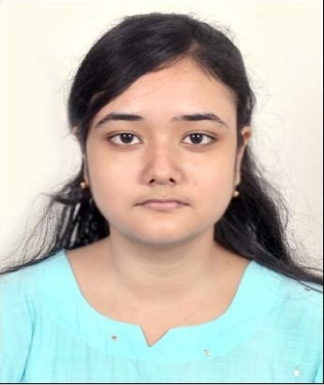

**Ayushi Keshri**



A4